WHAT THIS PROGRAM DOES:

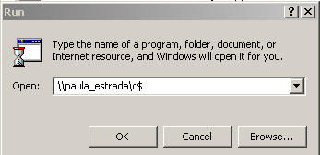
As a computer programmer, you may be developing one or more projects to run on certain computers on a network environment. Once the initial installation takes place for each computer, you may have a need to change the code for a program, recompile, and create a new EXE file,and copy the EXE file to each computer needing this program update on your network. NOTE: To use this demo, you must have System Admin rights or try typing in a UNC path and access their computer remotely. (Example Shown Right)

You could, of course, Use Start / Run / and type in the UNC path and dump the file to each computer (like illustrated above) - then copy the file over. There may even be other methods to do this, but the method I developed allows you to send the EXE file (or other file(s) if necessary), to each computer on the network (only those running your software) through its computer identification name.

This program was written about 1 ½ years ago – found partial code that was missing – so I’m uploading this for you’ll. Did some simple modifications to it before uploading it to PSC. Forms are quite simple and it uses DAO (I know it’s old) but still works very well. See for yourself – then change to ADO if you wish.

Now, since some users may be running the program you're trying to update them (unless you tell them all to get out), the data grid will inform you which of those computers were updated with your files and which were not - due to computer down - "Path not found" or any "Sharing violations". The database stores the computer identification name, program name, path to that particular program - i.e. "c:\program files\Tracesys\Trace.exe", executable version, date-time modified, etc. for each computer. You only add records to the Transfer.mdb database for computers using your software or other software. If a user has, say for example – 3 programs on his or her computer, then the computer name will appear in this Transfer.mdb 3 times - one for each program name with a different User Group code.

FILES IN THE ZIP:

This demonstration consists of 2 projects: TransferApp.vbp AND YourApp.vbp.
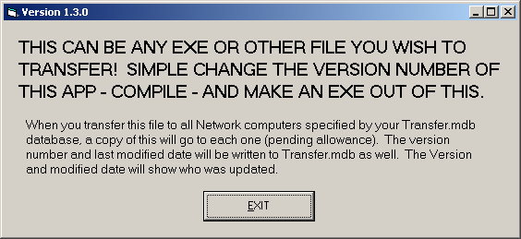
YourApp.vbp is a simple app that does nothing but show a screen (indicating the version number) - but compiling it yourself will give you an example EXE to transfer to your network computers. After you transfer it and they run it on their computer, the user will see the following is a screenshot of this app.

This YourApp.vbp and TransferApp.vbp does not require any outside OCX or DLL. You do have to reference the Microsoft Scripting Runtime.

TransferApp.vbp is the transferring program this submission deals with. Simply input the computer names and paths into the database as shown below:

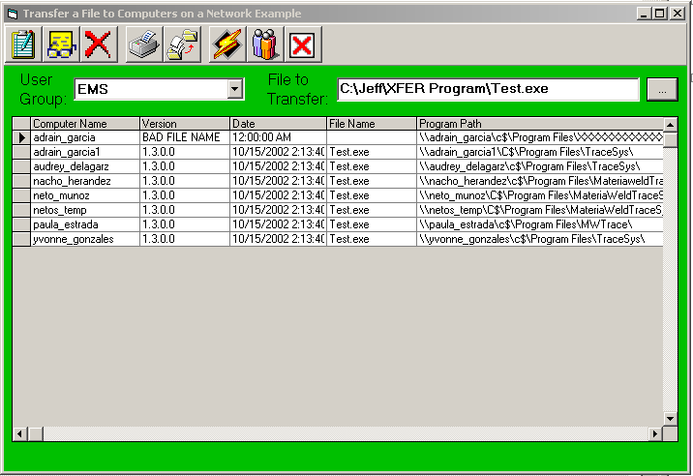

If you are familiar with a LAN, the computer name identifies your computer on a network. The Version is simply the version of an EXE or other file if can be extracted. Date is the modification date of the file. File name shows the name of the file transferred. Program Path tells your transfer where to send the file.

This example shows the user group = EMS. For example, if you were updating an INI file on all computers with “EMS” accounting software (whether or not your wrote it) installed on each, you would need to specify the path for each individual computer to the EMS’s directory or such. That is demonstrated in the Program Path shown in the illustration above.

“File to Transfer” allows you to select the file you want to transfer. As of now, you can only transfer one file at a time though and nothing exists that self-registers a file one transferred. If you decide to add these two features, please let me know.

Transfer.cfg is a configuration (or INI) file which you can edit.
STEPS to RUNNING THIS DEMONSTRATION:

- Unzip the file downloaded from PSC into a "new-named" directory - Whatever you want to name it. NOTE: Be sure all files unzipped are contained within the root of this directory – All files are in the same directory as Transfer.exe or Transfer.vbp.

- To use this software, be sure you plan the directory you want the YourApp program to appear. It can be any existing program’s directory (just to see that it copies it there) or you can create a blank directory on each computer on the network. Be sure to type in the UNC path correctly into the Transfer.mdb file for each machine and that you use the correct name for each. (The Transfer.mdb database holds the information needed for this program)

- Compile the YourApp.vbp program - This program is simply a test EXE that does really nothing. Change the YourApp version number each time you run this demo to see it change in the database.

- Set the Common Dialogue OPEN default directory by editing the TransferApp.cfg (text) file. Initial Dialogue Box Dir=

- Run the program and select your file.

TIP: Once you set up the first user group – you can simply copy in paste (in the mdb file) for computers that run more than one program. Only the path would probably change. NOTE: The database contains some sample data. Be sure to set up your own groups before running this and computer identifications before running this program.

Any other questions and comments – email to jeff.degregorio@gmftx.com

If you like this, please vote.

